Changes to tobacco regulations 2017

On the 20th May 2016 new regulations concerning tobacco products, herbal products for smoking and electronic cigarettes came into effect. These regulations include:
- Standardised “Plain” Packaging of Tobacco Products
- Regulations to implement the revised Tobacco Products Directive (TPD). The TPD has been transcribed into British Law through the Tobacco and Related Products Regulations 2016 (TRPR), it is through these regulations that the TPD is implemented and enforced.

This document has been produced by the Chartered Trading Standards Institute and Action on Smoking and Health (ASH), primarily for public health and enforcement professionals. It provides a summary of what the new regulations will cover, when they will be introduced, who will be responsible for enforcement and the penalties for non-compliance.

Standardised Packaging

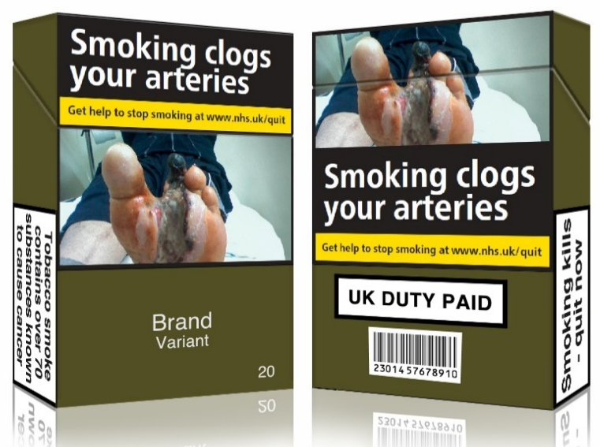
Standardised packaging, also known as plain packaging, refers to packaging that has had the attractive promotional branding removed, apart from the product name in standard typeface. In March 2015 MPs voted for standardised tobacco packaging regulations to be implemented by 20th May 2017.
This means that the appearance of all cigarettes and hand rolling packs will be standardised. This includes:

- The material, size, shape and opening mechanism of packaging;
- The colour of packaging and cigarettes;
- The font, colour, size, case and alignment of text.
For more details see here for The Standardised Packaging of Tobacco Products Regulations 2015.

Transitional period
Whilst all cigarettes and hand rolling tobacco products manufactured for sale in the UK had to comply with these regulations from 20th May 2016, there was a one year transitional period for the sell-through of old stock. From 21st May 2017 all tobacco products on sale in the UK must comply with these regulations. For more details see section 20 of the Regulations.

Enforcement
Local trading standards officers will be responsible for ensuring compliance with the law.
A person who produces or supplies a tobacco product in breach of the Regulations is guilty of an offence. For more details see section 15 of the Regulations.
- If found guilty by a Magistrates Court a person could face a prison sentence of up to three months, or a fine or both.
- If found guilty by a Crown Court a person could face a prison sentence of up to two years, or a fine or both.
On the 12th January 2017 the Consumer Rights (Enforcement and Amendments) Order 2016 (SI No. 1259) came into effect which ensures that enforcement officers have access to all enforcement powers under the Consumer Rights Act 2015.

Tobacco Products Directive (TPD)
In February 2014 the EU agreed a revised Tobacco Products Directive (TPD). The TPD strengthens the rules on how tobacco products are manufactured, produced and presented in the EU. It also includes a number of regulations regarding electronic cigarettes, herbal products for smoking and smokeless tobacco products.

Except where otherwise stated, the TPD was transposed into domestic law and implemented on the 20th May 2016 by virtue of the Tobacco and Related Products Regulations 2016.

The final Regulations are available here.

Tobacco
The TPD was transposed into domestic law on 20th May 2016, via the Tobacco and Related Products Regulations, except for two provisions with additional transition periods, set out below. Through the TPD a series of regulations have been imposed or updated which will:

- Prohibit cigarettes and roll-your-own tobacco with characterising flavours, including but not limited to fruit, spice, herbs, alcohol, candy, or vanilla. There is an additional transition period for the prohibition of menthol flavoured cigarettes until 20th May 2020.
- Set minimum contents for unit packs. Cigarette packs must contain at least 20 cigarettes and roll your own (hand rolled) tobacco packs must weigh at least 30 grams.
- Update the health warnings, including general, information and picture warnings, on packages of tobacco. Combined (picture and text) health warnings must cover 65% of the front and back of cigarette and roll-your-own tobacco packages. The TPD also allows Member States to go further, for example, by implementing standardised packaging legislation, as is the case in the UK, France and Ireland.
- Ban certain promotional and misleading descriptors on packaging of tobacco products such as “lite”, “natural” and “organic”.
- Introduce EU-wide tracking and tracing to combat illicit trade of tobacco products, following an additional transitional period of 20th May 2019 for cigarettes and hand rolling tobacco and 20th May 2024 for all other tobacco products.
- Allow Member States to either prohibit cross-border distance sales of tobacco products, or introduce a registration scheme for businesses engaged in such sales. (The UK will introduce a registration scheme).
- Require the tobacco industry to submit detailed reports to the Member States about the ingredients used in tobacco products.
- Require manufacturers to notify novel tobacco products in electronic form six months before the intended placing on the EU market.
- Strengthen reporting requirements for tobacco products.
- Introduce new labelling and reporting requirements for novel tobacco products and herbal products for smoking.

Additional transitional periods
Menthol cigarettes were given an additional four year phase-out period before they are banned outright on 20th May 2020. (See Article 7 of the Directive for more information).

EU-wide tracking and tracing will apply to cigarettes and hand-rolling tobacco from 20th May 2019 and to all other tobacco products from 20th May 2024. (See Article 15 of the Directive for more information).

Electronic cigarettes
- Electronic cigarettes which contain up to 20 mg per ml of nicotine will be regulated as consumer products as is required by the TPD (see Article 20 of the Directive). Zero nicotine products are not included in the TPD. Products containing over 20mg per ml of nicotine will need to have a medicinal license.

Under the TPD advertising, promotion and sponsorship of electronic cigarettes and re-fill containers is prohibited on cross-border media platforms including on the internet, television, radio, newspapers and magazines.

The new product rules under the TPD for electronic cigarettes will:

- Introduce a size limit for e-liquids of 10ml for dedicated refill containers and 2ml for disposable electronic cigarettes, cartridges and tanks.
- Require products to be child and tamper proof.
- Require the pack to include a health warning covering 30% of the surfaces of the unit packet and any outside packaging stating ‘This product contains nicotine which is a highly addictive substance.’
- Require instructions for use, information on addictiveness and toxicity on the packaging and accompanying information leaflet.
- Ban certain promotional and misleading descriptors on packaging.
- Ensure that all substances contained in the product and information on the product's nicotine content are declared on the label.
- Require manufacturers to inform Member States before placing new or modified products on the market and notify a range of product information concerning composition, emissions and sales/marketing data.
- Introduce a registration scheme for businesses engaged in cross-border distance sales of electronic cigarette products.
- Prohibit the advertising or promotion, directly or indirectly, of electronic cigarettes and re-fill containers on a number of media platforms, including on television, radio, newspapers and magazines;

Transitional periods
There was also a transitional period for electronic cigarettes, allowing non-compliant stock to be sold off. Non-compliant electronic cigarettes or refill containers could be sold until 20th November 2016. From 20th May 2017 all products on sale in the UK must be fully compliant with the TPD.
(See MHRA guidance for more information on the regulations and transitional arrangements).

Enforcement of the Tobacco and Related Products Regulations 2016
Each Weights and Measures authority in Great Britain and each District Council in Northern Ireland has the responsibility for the enforcement of these new Regulations. Effectively this means that local trading standards officers will be responsible for ensuring compliance with the law.

The proposed approach will be one of initial compliance building with businesses and a period of monitoring thereafter. Where noncompliance is found, further advice and guidance will be made available. Enforcement action may be taken where other attempts to secure compliance have failed.

A number of different offences are created in the Regulations including but not limited to:

- Any person that produces or supplies a tobacco product, or manufactures a tobacco product for export, in breach of a provision of labelling requirements or emissions and ingredients requirements commits an offence.
- Any person that breaches any provision relating to requirements for electronic cigarettes commits an offence.

The Regulations also include a defense provision for the person charged to prove that they exercised all due diligence to avoid the commission of the offence. This means that the person must provide evidence that they took reasonable steps and that they carried out suitable checks to avoid committing the offence. What constitutes due diligence is a matter to be considered in each individual case.

A person guilty of an offence under these Regulations is liable on (a) summary conviction (Magistrates court or equivalent) in England and Wales to imprisonment for a term not exceeding three months, or a fine or both; or in Scotland to imprisonment for a term not exceeding twelve months, or a fine not exceeding level 5 on the standard scale, or both; or in Northern Ireland, to imprisonment for a term not exceeding three months, or a fine not exceeding level 5 on the standard scale, or both; or (b) on conviction on indictment (crown court) to imprisonment for a term not exceeding 2 years, or a fine, or both.

Medicinally licensed electronic cigarettes
Products which contain more than 20 mg per ml of nicotine or which make smoking cessation claims will be prohibited unless they are licensed as medicines. These products will require authorisation from the Medicines and Healthcare products Regulatory Agency (MHRA) in the UK and this will be enforced by the MHRA.
Legal challenges to the regulations
The tobacco industry challenged both the Tobacco Products Directive through the European Court of Justice (ECJ) and standardised packaging regulations through the UK courts.

On 4th May 2016 the ECJ ruled that the TPD is lawful and that the tobacco industry’s challenge which sought to overturn the Directive was without foundation.

On 19th May 2016 the UK High Court ruled that standardised packaging is lawful.

On 30th November 2016 The Appeal Court rejected the appeal from three tobacco companies against the High Court ruling.

On 12th May 2017 the UK Supreme Court refused the tobacco industry the right to further appeal the High Court ruling, meaning there can be no more legal challenges to standardised packaging.

