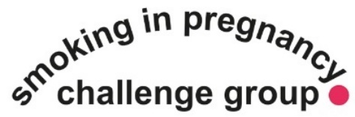
Smoking in Pregnancy Challenge Group resource request form
You can use this form to request physical copies of Smoking in Pregnancy Challenge Group resources.
This form should be completed by service leads to order resources for the whole service.
Please note: These resources should be ordered by maternity units and health visiting services to be used consistently across the service. If we get very small requests we may need to follow this up with your service manager. If you would like to order resources for your service, but do not work in a maternity unit please get in touch.
Please email your completed form to admin@smokefreeaction.org.uk
Resource |  | How it should be used |  | Who can order |  | Requested (Y/N)  You don’t need to tell us how many you want. We will calculate that using the info provided in the ‘Service information’ section below.
CO Test your breath handout  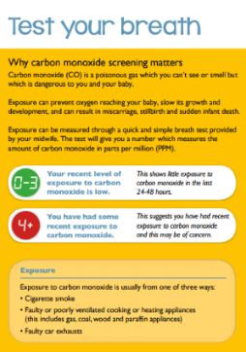 |  | - Designed to inform pregnant women and families about the dangers of exposure to carbon monoxide during pregnancy  - To be provided to all women at booking  - Polish and Romanian version available on request |  | Can be ordered by midwifery services
Carbon Monoxide Screening: advice for health professionals A5 leaflet  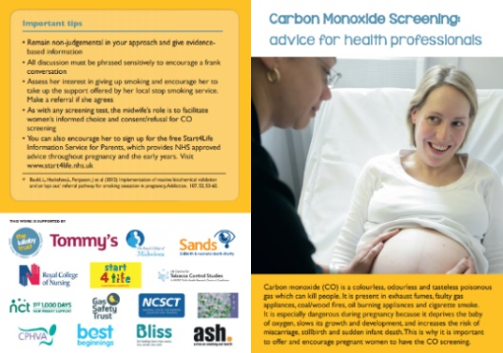 |  | - Designed to provide health professionals with key info about carrying out CO screening  - Not designed for service users  - 1 per health professional |  | Can be ordered by midwifery services
Use of electronic cigarettes before, during and after pregnancy: Key messages for health professionals working with pregnant women and their babies (A5) |  | - Designed to inform health professionals about the use of e-cigarettes in pregnancy and support conversations with pregnant women who are enquiring about e-cigarettes  - Not designed for service users |  | Can be ordered by midwifery and health visiting services
E-cigarettes in pregnancy: Infographic for pregnant women and families (A5) |  | - Designed to inform women and families about the use of e-cigarettes in pregnancy  - Can be given to service users |  | Can be ordered by midwifery and health visiting services
Smoking and your baby: advice for parents (A5) |  | - These should be used by health visitors to support conversations with women and families about the harms of smoking and secondhand smoke and the benefits of a smokefree home  - Can be given to service users |  | Can be ordered by midwifery and health visiting services
Secondhand smoke postcards (2-sided)  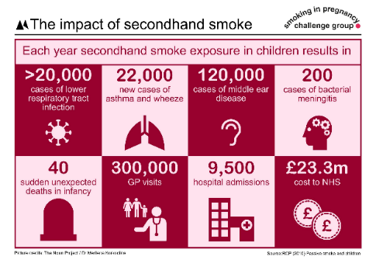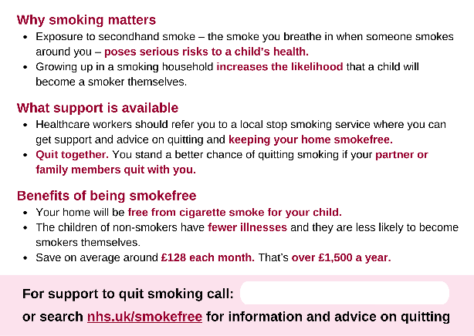 |  | - These should be used directly with women and families as conversation aids or as handouts. They include messages targeted at women and families who have recently had a baby, are currently pregnant or are planning for another child  - Includes 4 postcard variants with information about the harms of SHS exposure, the impact of smoking during pregnancy, what support is available and the benefits of being smokefree  - The postcards include space for professionals to write the phone number of the local stop smoking service  - Can be given to service users |  | Can be ordered by midwifery and health visiting services |  | CURRENTLY OUT OF STOCK
Delivering very brief advice postcard (2-sided)  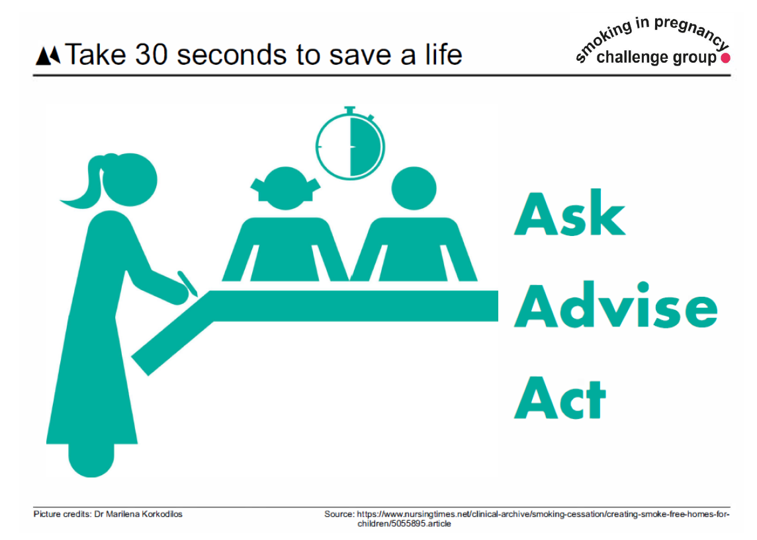  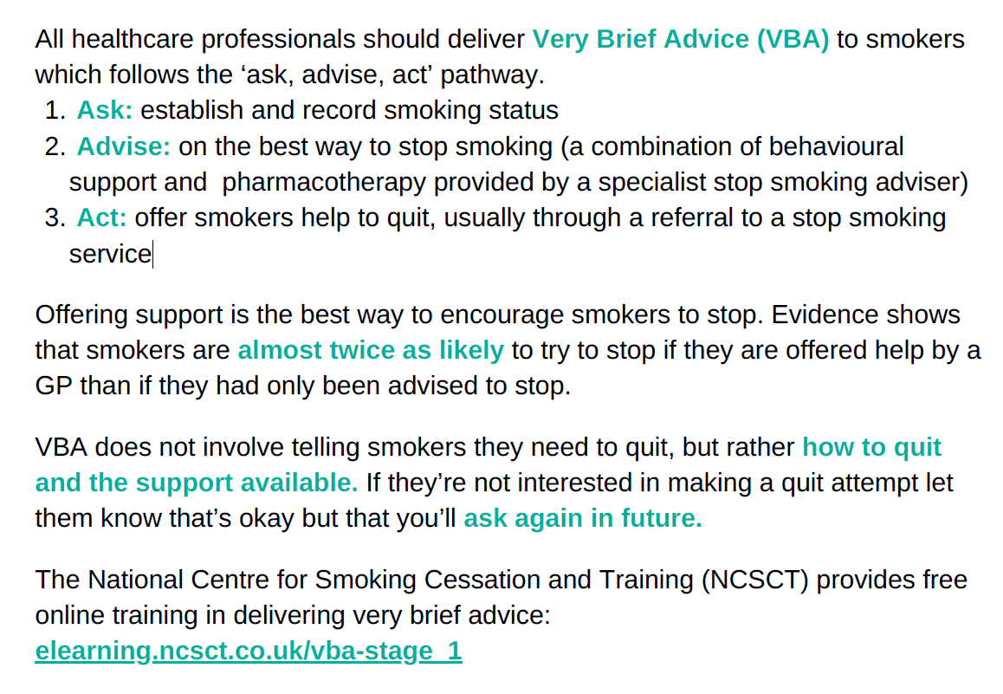 |  | - Designed as a training aid to inform health professionals about delivering very brief advice (VBA) to pregnant women  - Includes a link to free e-learning on VBA provided by the National Centre for Smoking Cessation and Training  - Not designed for service users |  | Can be ordered by health visiting services
Service information (ESSENTIAL)
This helps us calculate how many resources your service will need
Number of births per year |  |  | SATOD rate
Number of staff who will use the resources
Delivery Information (ESSENTIAL)
Name
Email
Contact number
Job title
Organisation
Delivery address

